Platonic solids

Definition
# Source: AI Source: Provided by: [Data Path: Persons Table -> ID Column: 1, Name_En Column: Motasem Essam] -> From: [ChatGPT] on [7/25/2026]
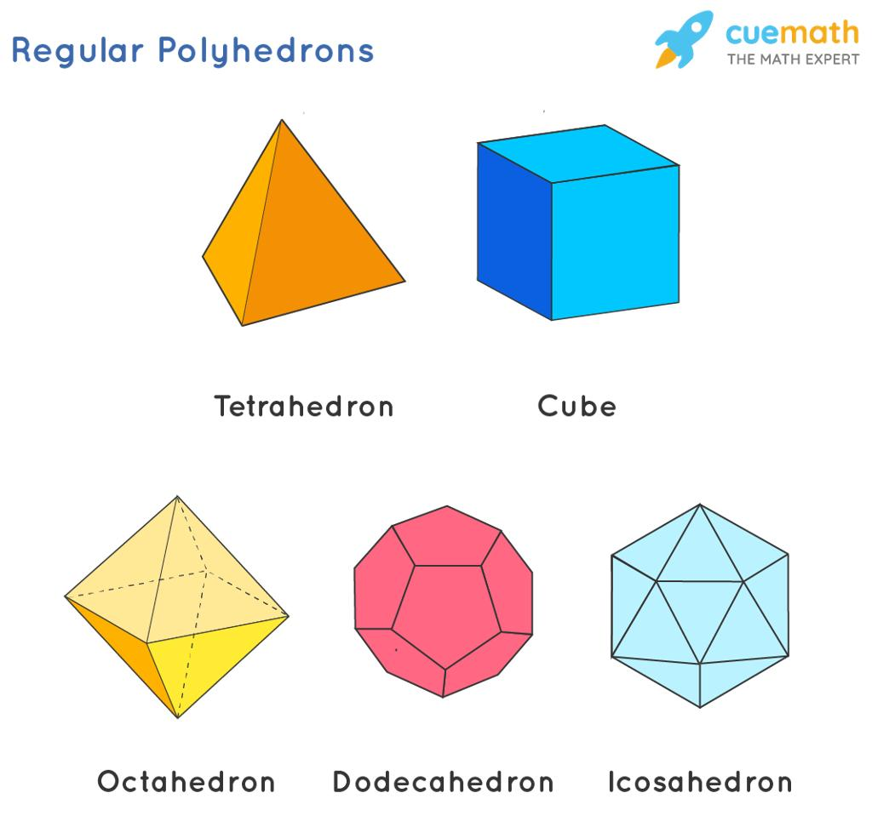
A Platonic solid is a convex polyhedron whose faces are congruent regular polygons, with the same number of faces meeting at every vertex.
There are exactly five Platonic solids in three-dimensional Euclidean geometry:
- Tetrahedron
- Cube (hexahedron)
- Octahedron
- Dodecahedron
- Icosahedron
They are also called the five regular convex polyhedra.

Simple Definition
# Source: AI Source: Provided by: [Data Path: Persons Table -> ID Column: 1, Name_En Column: Motasem Essam] -> From: [ChatGPT] on [7/25/2026]
A Platonic solid is a three-dimensional solid with identical regular polygon faces arranged in exactly the same way at every vertex.
For example, a cube is a Platonic solid because all six faces are congruent squares, and three faces meet at every vertex.

Classification Tree
# Source: AI Source: Provided by: [Data Path: Persons Table -> ID Column: 1, Name_En Column: Motasem Essam] -> From: [ChatGPT] on [7/25/2026]
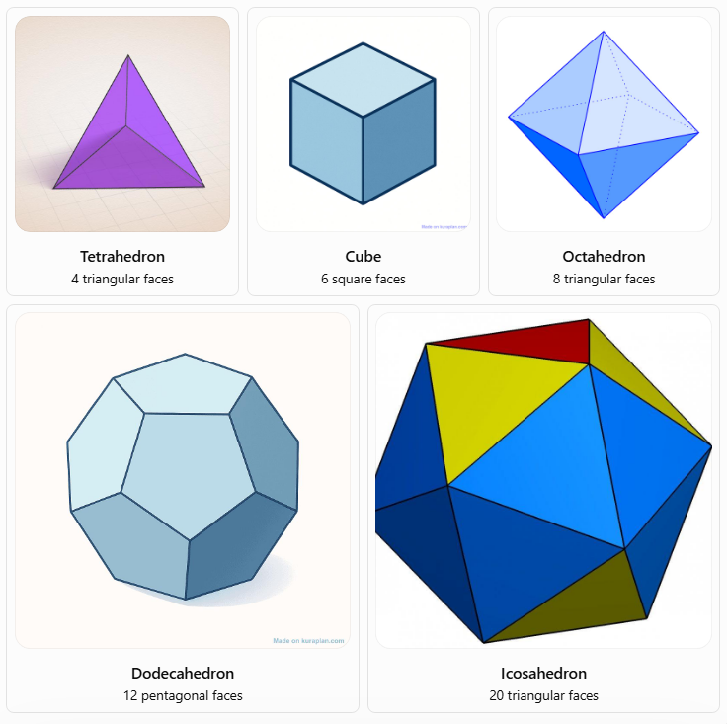
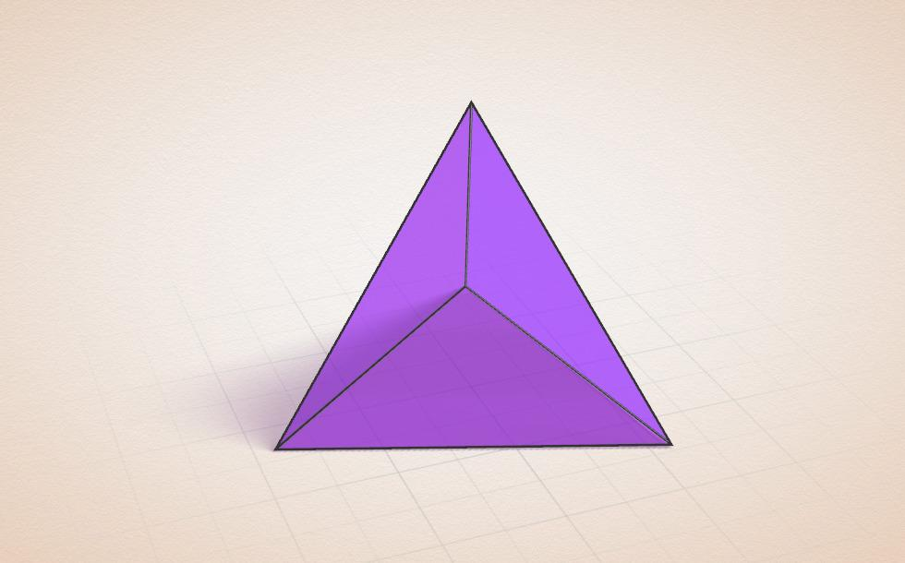
Tetrahedron
4 triangular faces
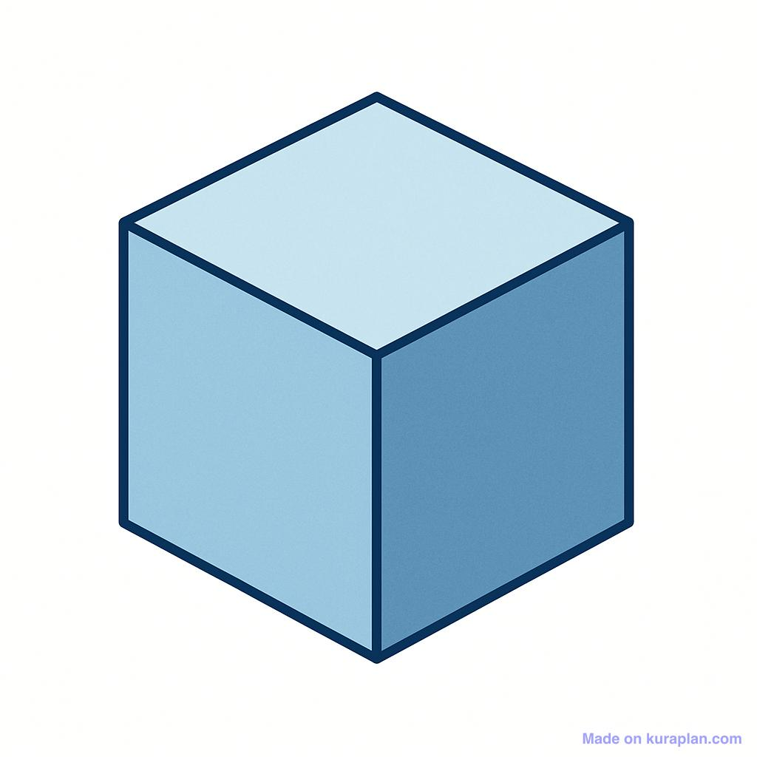
Cube
6 square faces
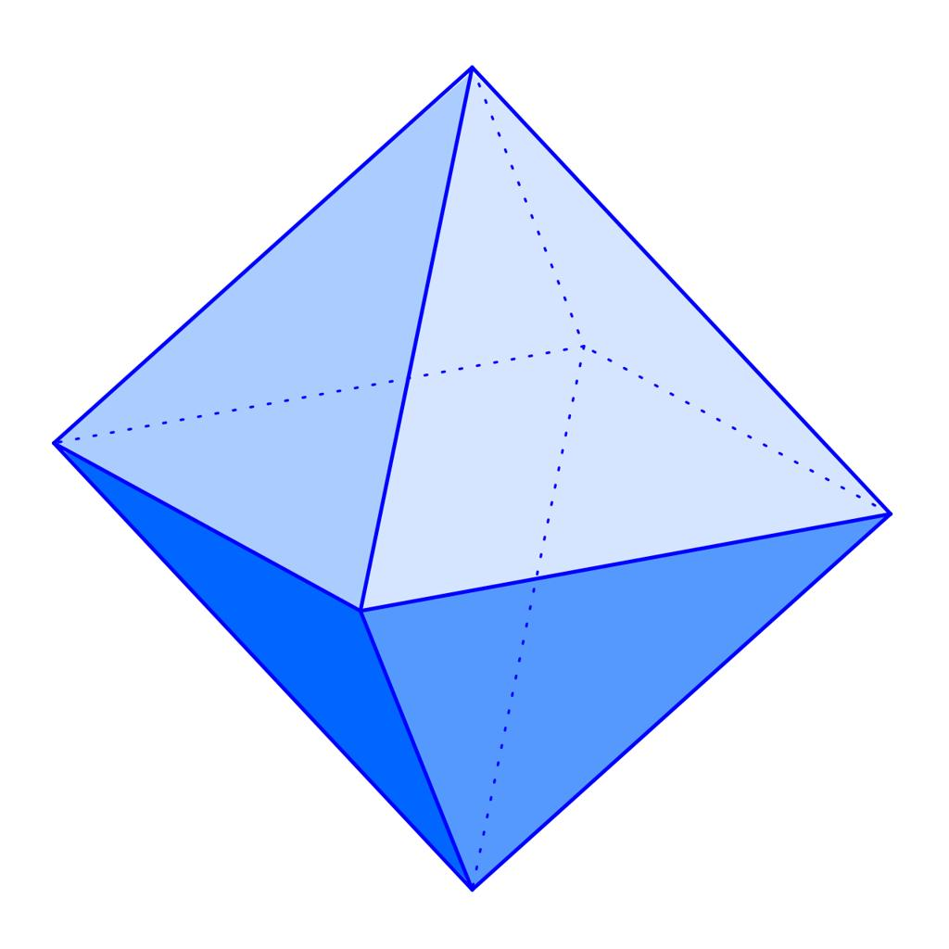
Octahedron
8 triangular faces
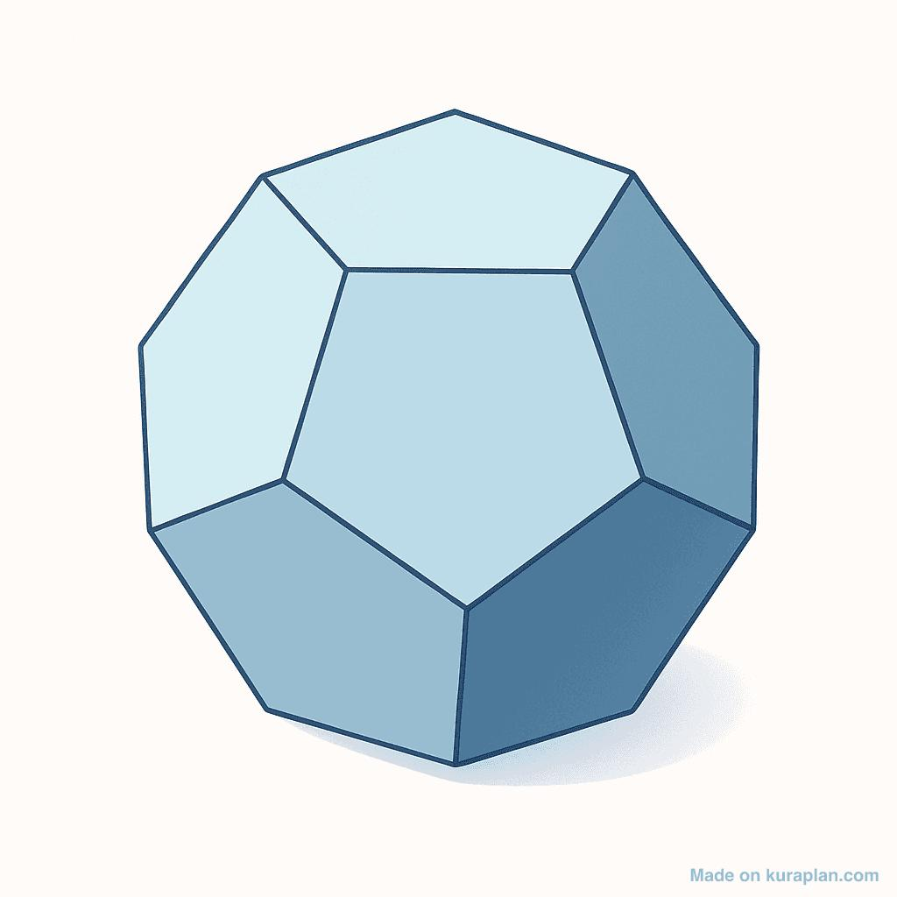
Dodecahedron
12 pentagonal faces
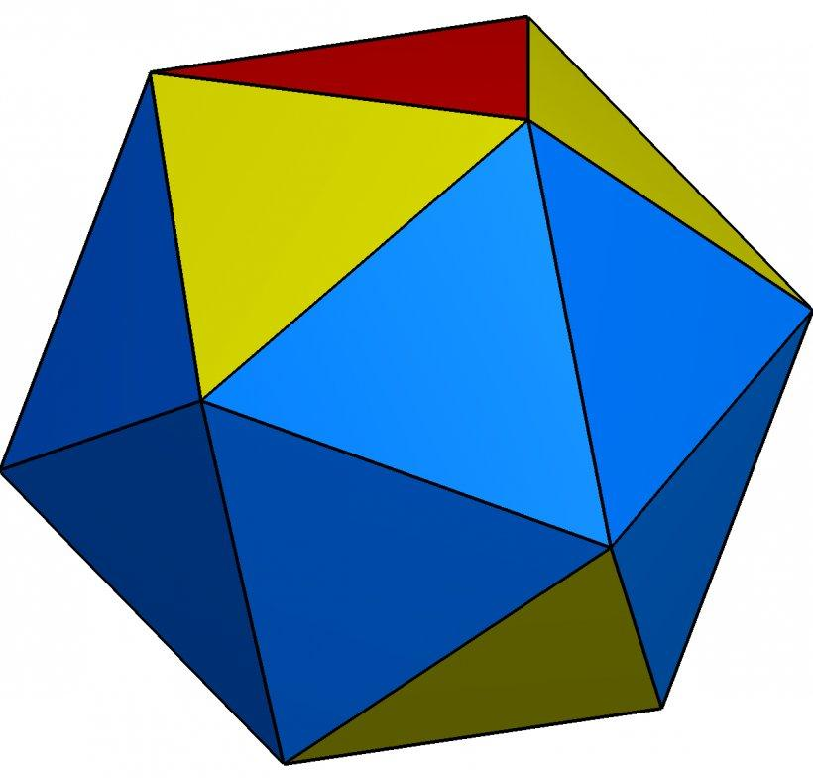
Icosahedron
20 triangular faces

The Five Platonic Solids

1. Tetrahedron
# Source: AI Source: Provided by: [Data Path: Persons Table -> ID Column: 1, Name_En Column: Motasem Essam] -> From: [ChatGPT] on [7/25/2026]
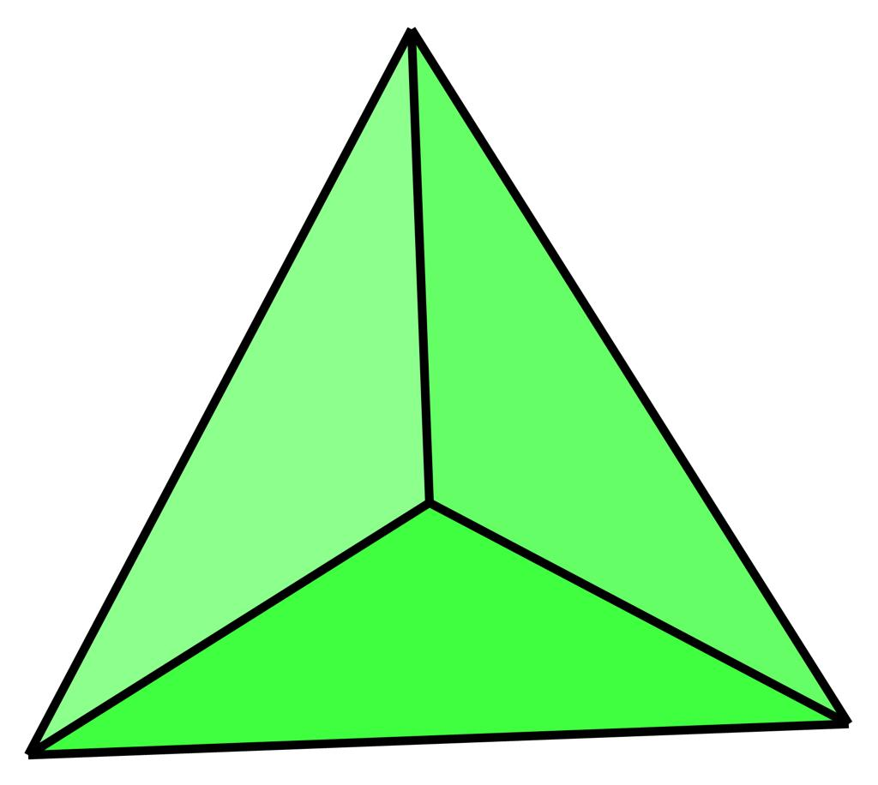
A regular tetrahedron has four congruent equilateral-triangle faces.
- Faces: $F=4$
- Edges: $E=6$
- Vertices: $V=4$
- Faces meeting at each vertex: $3$
- Face shape: Equilateral triangle
It has the fewest faces of the five Platonic solids.

2. Cube (Regular Hexahedron)
# Source: AI Source: Provided by: [Data Path: Persons Table -> ID Column: 1, Name_En Column: Motasem Essam] -> From: [ChatGPT] on [7/25/2026]
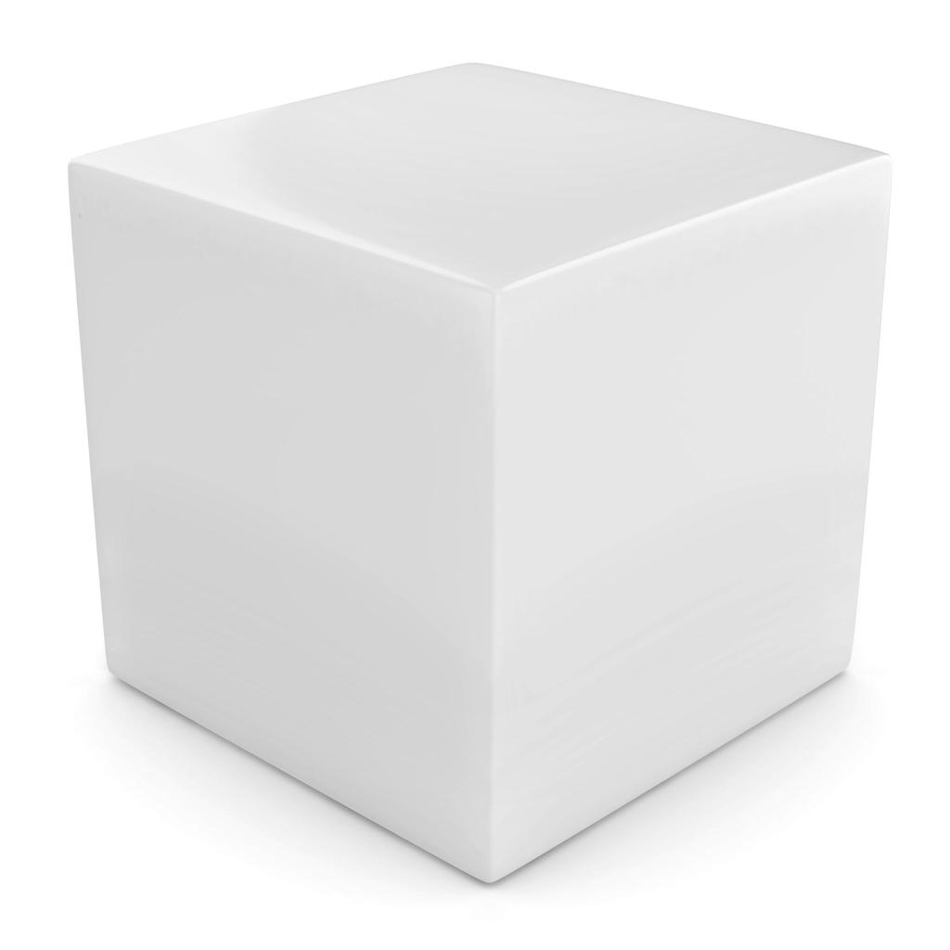
A cube has six congruent square faces.
- Faces: $F=6$
- Edges: $E=12$
- Vertices: $V=8$
- Faces meeting at each vertex: $3$
- Face shape: Square
The cube is also called a regular hexahedron. It is the only Platonic solid whose faces are squares.

3. Octahedron
# Source: AI Source: Provided by: [Data Path: Persons Table -> ID Column: 1, Name_En Column: Motasem Essam] -> From: [ChatGPT] on [7/25/2026]
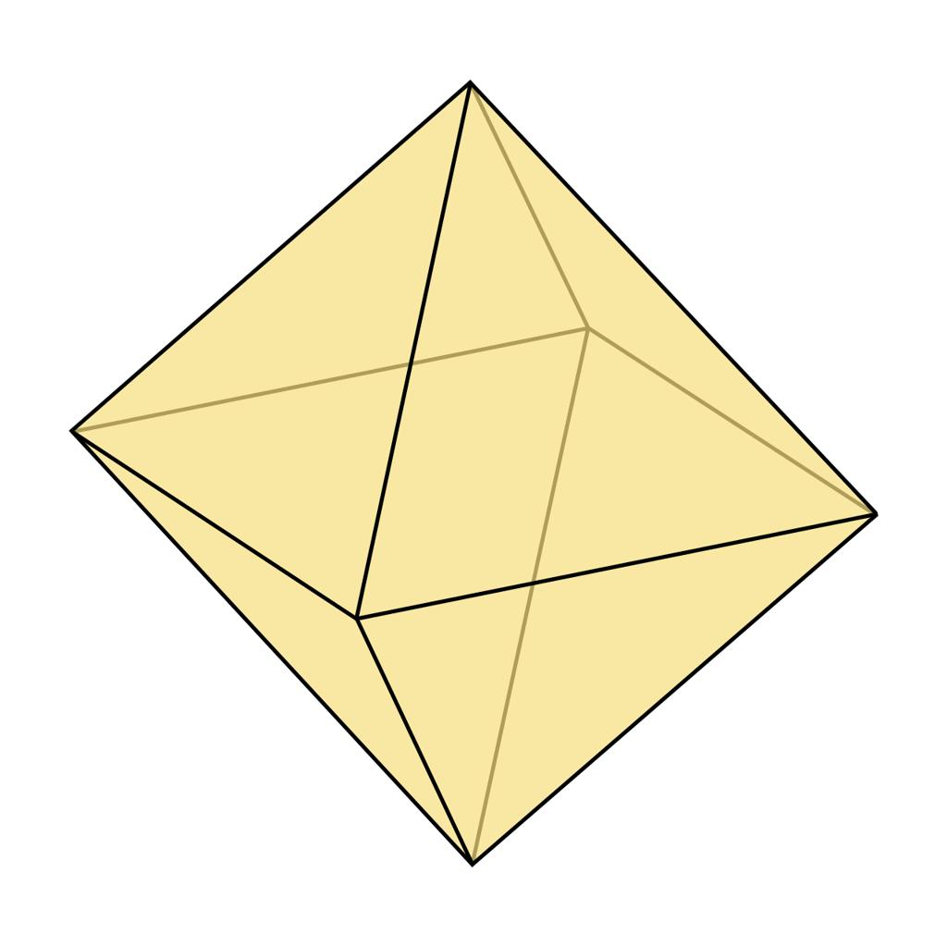
A regular octahedron has eight congruent equilateral-triangle faces.
- Faces: $F=8$
- Edges: $E=12$
- Vertices: $V=6$
- Faces meeting at each vertex: $4$
- Face shape: Equilateral triangle
It can be visualized as two square pyramids joined base-to-base.

4. Dodecahedron
# Source: AI Source: Provided by: [Data Path: Persons Table -> ID Column: 1, Name_En Column: Motasem Essam] -> From: [ChatGPT] on [7/25/2026]
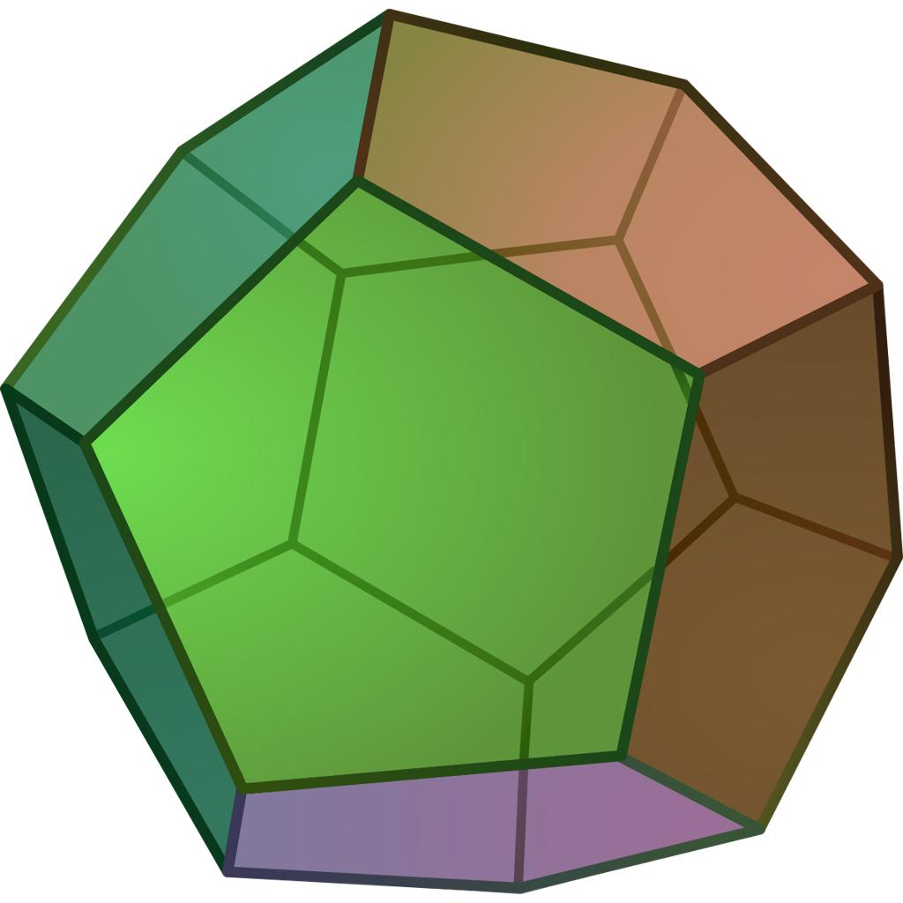
A regular dodecahedron has twelve congruent regular pentagonal faces.
- Faces: $F=12$
- Edges: $E=30$
- Vertices: $V=20$
- Faces meeting at each vertex: $3$
- Face shape: Regular pentagon
It is the Platonic solid with regular pentagonal faces.

5. Icosahedron
# Source: AI Source: Provided by: [Data Path: Persons Table -> ID Column: 1, Name_En Column: Motasem Essam] -> From: [ChatGPT] on [7/25/2026]
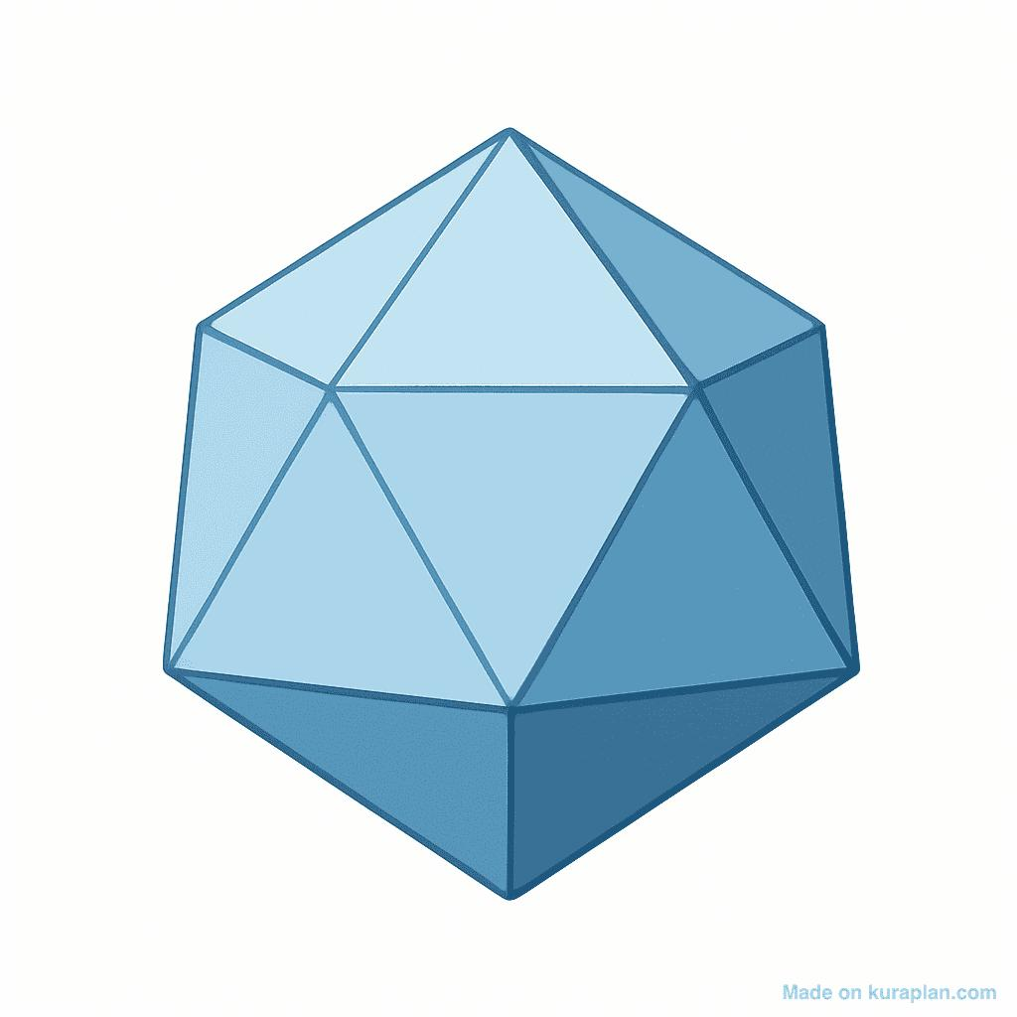
A regular icosahedron has twenty congruent equilateral-triangle faces.
- Faces: $F=20$
- Edges: $E=30$
- Vertices: $V=12$
- Faces meeting at each vertex: $5$
- Face shape: Equilateral triangle
It has the greatest number of faces among the five Platonic solids.

Comparison Table of the Five Platonic Solids
# Source: AI Source: Provided by: [Data Path: Persons Table -> ID Column: 1, Name_En Column: Motasem Essam] -> From: [ChatGPT] on [7/25/2026]
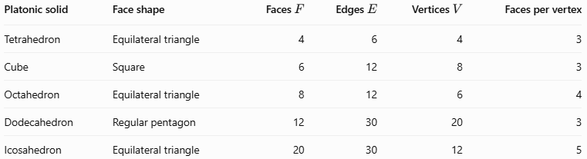
Platonic solid | Face shape | Faces $F$ | Edges $E$ | Vertices $V$ | Faces per vertex
Tetrahedron | Equilateral triangle | 4 | 6 | 4 | 3
Cube | Square | 6 | 12 | 8 | 3
Octahedron | Equilateral triangle | 8 | 12 | 6 | 4
Dodecahedron | Regular pentagon | 12 | 30 | 20 | 3
Icosahedron | Equilateral triangle | 20 | 30 | 12 | 5
Important observation: Three of the five Platonic solids have triangular faces: the tetrahedron, octahedron, and icosahedron. The cube has square faces, and the dodecahedron has pentagonal faces.

Key Characteristics of Platonic Solids
# Source: AI Source: Provided by: [Data Path: Persons Table -> ID Column: 1, Name_En Column: Motasem Essam] -> From: [ChatGPT] on [7/25/2026]
A polyhedron is a Platonic solid when it satisfies all of these conditions:
- Convexity: The solid has no inward dents.
- Regular faces: Every face is a regular polygon.
- Congruent faces: All faces are identical in shape and size.
- Uniform vertices: The same number of faces meet at every vertex.
- Consistent structure: The faces, edges, and vertices form a regular three-dimensional arrangement.
For each Platonic solid, all edges have equal length. All vertices are equivalent under the solid's symmetries.

Euler's Formula for Platonic Solids
# Source: AI Source: Provided by: [Data Path: Persons Table -> ID Column: 1, Name_En Column: Motasem Essam] -> From: [ChatGPT] on [7/25/2026]
Every Platonic solid satisfies Euler's formula for convex polyhedra:
$$\boxed{V-E+F=2}$$
where:
- $V$ = number of vertices
- $E$ = number of edges
- $F$ = number of faces
Worked example: The dodecahedron
A dodecahedron has 20 vertices, 30 edges, and 12 faces.
$$V-E+F=20-30+12$$
$$=2$$
Therefore, the dodecahedron satisfies Euler's formula.
The same formula works for all five Platonic solids.

Why Are There Exactly Five Platonic Solids?
# Source: AI Source: Provided by: [Data Path: Persons Table -> ID Column: 1, Name_En Column: Motasem Essam] -> From: [ChatGPT] on [7/25/2026]
The reason comes from the angles of regular polygons.
For a convex polyhedron, the interior angles of the faces meeting at a vertex must add up to less than ${360}^{∘}$. Otherwise, the faces cannot bend around the vertex to form a convex corner.
The interior angle of a regular $p$-sided polygon is:
$$α=\frac{\left(p-2\right){180}^{∘}}{p}$$
If $q$ faces meet at each vertex, then:
$$qα<{360}^{∘}$$
Substituting the angle formula gives:
$$q\frac{\left(p-2\right){180}^{∘}}{p}<{360}^{∘}$$
This condition allows only a limited number of regular-polygon combinations.
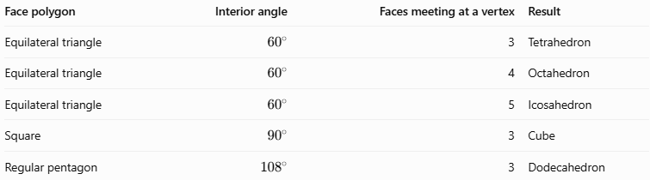
Face polygon | Interior angle | Faces meeting at a vertex | Result
Equilateral triangle | $${60}^{∘}$$ | 3 | Tetrahedron
Equilateral triangle | $${60}^{∘}$$ | 4 | Octahedron
Equilateral triangle | $${60}^{∘}$$ | 5 | Icosahedron
Square | $${90}^{∘}$$ | 3 | Cube
Regular pentagon | $${108}^{∘}$$ | 3 | Dodecahedron
For triangles, six faces meeting at a vertex would give $6\left({60}^{∘}\right)={360}^{∘}$, which cannot form a convex corner. For squares, four would give ${360}^{∘}$, and for regular pentagons, three already exceed ${360}^{∘}$.
This explains why there are exactly five convex Platonic solids.

Mathematical Formulas for a Platonic Solid
# Source: AI Source: Provided by: [Data Path: Persons Table -> ID Column: 1, Name_En Column: Motasem Essam] -> From: [ChatGPT] on [7/25/2026]
Let $a$ represent the edge length of the solid.
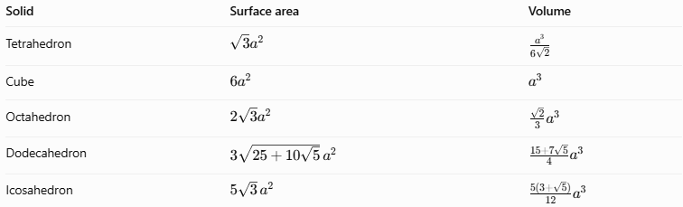
Solid | Surface area | Volume
Tetrahedron | $$\sqrt{3}a^{2}$$ | $$\frac{a^{3}}{6\sqrt{2}}$$
Cube | $$6a^{2}$$ | $$a^{3}$$
Octahedron | $$2\sqrt{3}a^{2}$$ | $$\frac{\sqrt{2}}{3}a^{3}$$
Dodecahedron | $$3\sqrt{25+10\sqrt{5}} a^{2}$$ | $$\frac{15+7\sqrt{5}}{4}a^{3}$$
Icosahedron | $$5\sqrt{3} a^{2}$$ | $$\frac{5\left(3+\sqrt{5}\right)}{12}a^{3}$$
These formulas assume a regular solid, so every edge has the same length.
Worked example: Surface area and volume of a cube
Suppose a cube has edge length $a=4\text{ cm}$.
Surface area:
$$A=6a^{2}=6\left(4^{2}\right)=\boxed{96{\text{ cm}}^{2}}$$
Volume:
$$V=a^{3}=4^{3}=\boxed{64{\text{ cm}}^{3}}$$

Platonic Solids Compared with Other Polyhedra
# Source: AI Source: Provided by: [Data Path: Persons Table -> ID Column: 1, Name_En Column: Motasem Essam] -> From: [ChatGPT] on [7/25/2026]
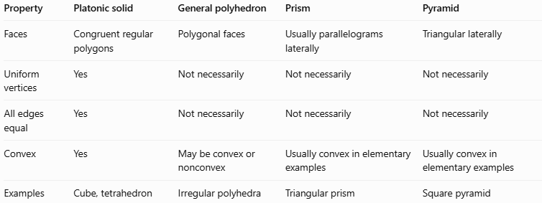
Property | Platonic solid | General polyhedron | Prism | Pyramid
Faces | Congruent regular polygons | Polygonal faces | Usually parallelograms laterally | Triangular laterally
Uniform vertices | Yes | Not necessarily | Not necessarily | Not necessarily
All edges equal | Yes | Not necessarily | Not necessarily | Not necessarily
Convex | Yes | May be convex or nonconvex | Usually convex in elementary examples | Usually convex in elementary examples
Examples | Cube, tetrahedron | Irregular polyhedra | Triangular prism | Square pyramid
A cube is both a Platonic solid and a prism. However, a rectangular prism with unequal edge lengths is not a Platonic solid because its faces are not all congruent squares.
A regular tetrahedron is both a Platonic solid and a triangular pyramid. A general square pyramid is not a Platonic solid.

Applications of Platonic Solids
# Source: AI Source: Provided by: [Data Path: Persons Table -> ID Column: 1, Name_En Column: Motasem Essam] -> From: [ChatGPT] on [7/25/2026]
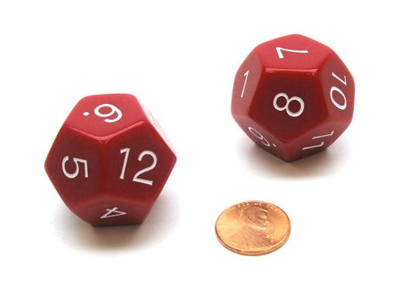
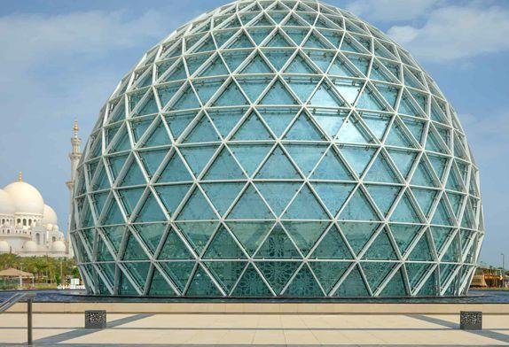
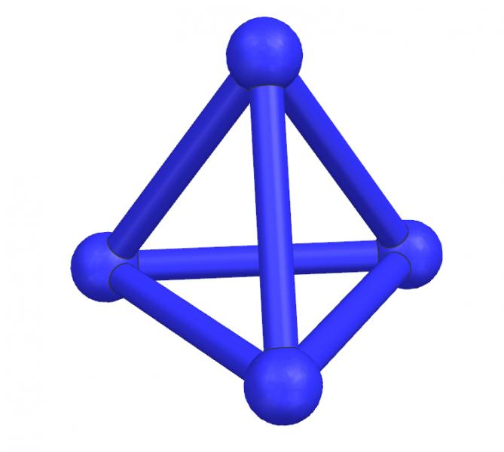
- Dice and games: Cubes are common dice, while dodecahedra and icosahedra are used in role-playing games.
- Architecture: Platonic solids inspire geometric structures and design patterns.
- Chemistry: Regular polyhedral arrangements help illustrate molecular and atomic structures, although actual molecules need not be perfect Platonic solids.
- Mathematics: They demonstrate symmetry, polygon geometry, spatial reasoning, and Euler's formula.
- Computer graphics: Their regular geometry is useful in modeling, mesh design, and three-dimensional visualization.

Key Points
# Source: AI Source: Provided by: [Data Path: Persons Table -> ID Column: 1, Name_En Column: Motasem Essam] -> From: [ChatGPT] on [7/25/2026]
- There are exactly five Platonic solids in three-dimensional Euclidean geometry.
- Their names are tetrahedron, cube, octahedron, dodecahedron, and icosahedron.
- Every face is a congruent regular polygon.
- The same number of faces meet at every vertex.
- Every edge has the same length within a given Platonic solid.
- All five satisfy Euler's formula: $V-E+F=2$.
- The tetrahedron has the fewest faces, while the icosahedron has the most.
- The cube is the only Platonic solid with square faces; the dodecahedron is the only one with pentagonal faces.

Conclusion
# Source: AI Source: Provided by: [Data Path: Persons Table -> ID Column: 1, Name_En Column: Motasem Essam] -> From: [ChatGPT] on [7/25/2026]
Platonic solids are the five convex polyhedra with the highest degree of regularity: congruent regular polygonal faces and identical vertex arrangements. Their properties connect polygon angles, three-dimensional geometry, symmetry, surface area, volume, and Euler's formula.

